Helhoughton Parish Council
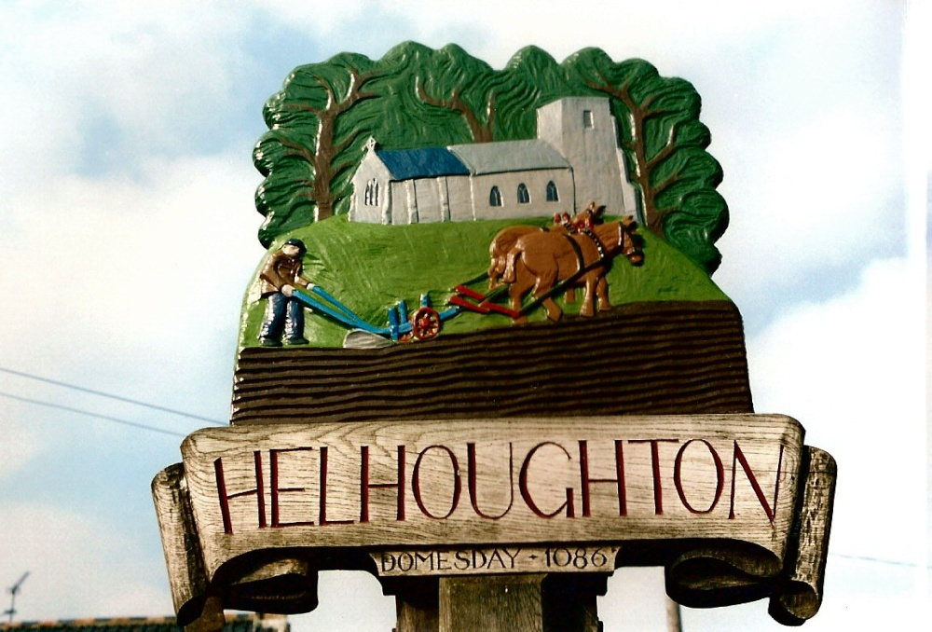
Meeting Minutes
Monday 10th November 2025

Parish Councillors present: Tim Harris (Chairman), Mel Lacey-Freeman, Kit Price-Moss, Tim Pinkerstone, Paul Flint. Also in attendance: Tom FitzPatrick (County Councillor) and Maxine Hayes (Parish Clerk). There were 2 members of the public present.

1. Welcome and receive apologies for absence
The Chairman welcomed those present. Apologies received from Sean Millard. Apologies accepted.
2. To receive declarations of interest in items on the agenda and consider any requests for dispensations
There were none.
3. To approve the minutes of the meetings held on 8 September 2025.
The minutes were approved without amendment and signed by the Chairman as a correct record.
4. To report progress on items not on the agenda from the last meeting
None.
5. To receive reports from NCC Cllr & NNDC Cllr, if attending.
Cllr FitzPatrick reported on the Local Government reorganisation. A report had been circulated to councillors. A short discussion on the nationalisation of the railways took place.
District Council – no report.
6. Open forum for Public Participation: an opportunity to hear from members of the public
A resident informed the County Councillor that there had been no weed spraying of the pavements this year. Concern was expressed that some of the pavements were covered in moss which can get very slippery. Councillor Fitzpatrick agreed to check this out.
7. To receive updates from councillors & working group members
7.1 Update from the Friends of Helhoughton Playground – Nothing to report.
Councillor Harris gave an update on the extension to the play area which would be cleared by Raynham Estate before handing over to the Parish. The Parish Council would look for funding to fence the area to make it safe.
The Clerk was asked to check details of the pest control contract.
7.2 To receive SAM2 data report
No report due to issues with the laptop.

7.3 Helhoughton Cemetery & Church yard report
The church wall repairs were now complete. The Clerk was asked to write to the contractors on behalf of the Council and thank them for their excellent work.
The new bin had been added to the waste collection contract.
7.4 Village Hall Committee report
It was reported that the Halloween event went very well. The new curtains should be in place in the next couple of weeks. A short discussion took place over the installation of wi-fi and the installation of a smoke detector (as required by law).
7.5 Solar Fund Committee report
The next round of funding would be available in May/June 2026.
7.6 Future of Village Newsletter
A volunteer had come forward to take over the production of the newsletter. It was agreed that the Parish Council would like submit a regular report.
8. Open Spaces
Nothing to report.
9. Planning Matters
No planning matters.
9.2 To receive and consider new applications
There were none.
10. To receive and consider clerks report and correspondence
The Clerk gave the following report to the meeting:
- Assertion 10 Digital and Data Compliance training
As required it was agreed that the Clerk would research changing over the email addresses to a gov.uk address for all councillors and the clerk which would be linked to the website.
The policies recommended in the clerks report would be approved at the January meeting.
- Junior Swing – The Clerk had contacted another local engineering company to look at the swing. They had agreed to report back in the next couple of weeks with their findings.
- Bank – the mandate had now been changed and the Clerk had been added as the administrator.
- Defib training – to be deferred until January/February 2026.
- Report to NCC highways regarding the blocked drainpipes in the ditches near the play area The Street. No action was taken as they found no issues with flooding. The Chairman agreed to contact highways about this and other flooding issues.
- Shared costs with Raynham PC – It was agreed to share the office costs with Raynham Parish Council. Shared costs for Microsoft Office, Anti- Virus and the clerks mobile phone were approved.
Correspondence
- Norfolk Assoc of Local Councils Newsletter
- TRO Road Closure C333 at Junction with C337 Common Road – UK Power Networks
- Norfolk Healthwatch Newsletter
- NNDC – Details of Local Government reorganisation events for Town & Parish Councils 13/11 Blakeney 18/11 Hickling
- Norfolk County Council Budget Consultation 27th October – 15th December
11. Financial matters
11.1 To approve the bank reconciliation and payment of accounts list:
The Council RESOLVED to approve the bank reconciliation and payments list
below.

Date | Supplier | Description | Amount
18.9.25 | E G Groundscare | Grounds Maintenance | £ 1,483.00
29.9.25 | K & M Lighting | SL Maintenance | £ 11.09
29.9.25 | Mcaffee 1/3 | Anti Virus | £ 11.66
29.9.25 | Clerk | Expenses, office costs, stationery | £ 18.64
29.9.25 | Clerk | Salary Sept | £ 39.31
29.9.25 | Clerk | Salary Oct | £ 157.24
29.9.25 | HMRC | PAYE | £ 49.00
29.9.25 | E G Groundscare | Grounds Maintenance | £ 593.28
29.9.25 | Grocott & Murfitt | Traffic Mngm Wall repairs | £ 2,394.00
29.9.25 | Grocott & Murfitt | Churchyard wall repairs | £ 9,967.00
10.11.25 | E G Groudscare1326 | Grounds Maintenance | £ 296.64
10.11.25 | Clerk | Reimb training assertion 10 | £ 8.00
10.11.25 | Raynham PC | shared office costs mobile | £ 12.66
Total |  |  | £ 15,041.52
Income
30.9.25 | NNDC | Precept | £ 4,394.00
20.10.25 |  | Grant | £ 8,306.00
30.10.25 | Barclays | Interest | £ 27.19
Total |  |  | £ 12,727.19

11.2 Approved and added to payments list
11.3 To review 6 months budget v expenditure and set precept for 2026/27
Unanimously approved to add a 5% increase to the precept and request the amount of £9227.40 for the financial year 2026/27.
12. To receive any items for inclusion on the next agenda and to note the date of the next meeting
Dates approved for 2026
Monday 19th January 7.00pm
Monday 9th March 7.00pm
Monday 11th May 7.00pm
Monday 13th July 7.00pm
Monday 7th September 7.00pm (brought forward)
Monday 9th November

Signed by Chairman: ...................................................................

Date: ...........................................

